



Essay / Assignment Title: Predictive Analytics and Machine Learning Project Report

Programme title:

Name:

Year:

CONTENTS

CONTENTS 2
1. INTRODUCTION 5
Importance of Predictive Analytics and Machine Learning 5
Business Problem 5
2. CHAPTER ONE: PROBLEM FORMULATION 6
3. CHAPTER TWO: DATA COLLECTION AND PREPARATION 7
Data Collection 7
Data Preprocessing 7
Handling Missing Values 7
Feature Scaling 8
Feature Selection 8
Data Splitting 9
4. CHAPTER FOUR: EXPLORATORY DATA ANALYSIS (EDA) 10
5. CHAPTER FIVE: MODEL SELECTION AND IMPLEMENTATION 15
Machine Learning Models Selected 15
1. Logistic Regression 15
2. Random Forest Classifier 15
3. Support Vector Machines (SVM 16
Hyperparameter Tuning and Feature Selection 16
Hyperparameter Tuning 17
Feature Selection 18
6. CHAPTER SIX: MODEL EVALUATION 20
Evaluation Metrics 20
Logistic Regression 20
Random Forest 21
Support Vector Machine (SVM) 21
Implications 22
7. CONCLUSION AND RECOMMENDATIONS 23
8. PROJECT REFLECTION 24
9. BIBLIOGRAPHY 25
APPENDIX (if necessary) 26

Statement of compliance with academic ethics and the avoidance of plagiarism

I honestly declare that this dissertation is entirely my own work and none of its part has been copied from printed or electronic sources, translated from foreign sources and reproduced from essays of other researchers or students. Wherever I have been based on ideas or other people texts I clearly declare it through the good use of references following academic ethics.
(In the case that is proved that part of the essay does not constitute an original work, but a copy of an already published essay or from another source, the student will be expelled permanently from the postgraduate program).

Name and Surname (Capital letters):

.......................................................................................................................................

Date: ........................./........../.........

INTRODUCTION

Importance of Predictive Analytics and Machine Learning (Vellido, A., 2020)
These elements are crucial to make precise executive decisions based on data collected. They empower organizations to extend present paradigms and make clearer forecasts to embrace an explicit conclusion about the exact determinations to make in the future. It is seen that with the help of machine learning models in data analysis, different patterns are created which, in turn, lead to better predictions and decision making, over all enhancing the efficiency and competitiveness (Bharadiya, J.P., 2023). Furthermore, these technologies provide businesses and institutions with a competitive advantage in dynamic environments.

Business Problem
The aim of developing this Heart Disease Prediction model is to assist figures of authority in diagnosing cardiac health conditions under the constraint of time (Kumar, Y., Koul, A., Singla, R. and Ijaz, M.F., 2023). Cardiovascular diseases remain the number one killer of people on the planet. While using it to predict the likelihood of heart disease in patients, the providers can easily prevent the occurrence of on or enhance the care given to the patients. Based on a set of data with features of different patients, the purpose of this study is to determine the high-risk people. It also helps in early treatment and prevents cases of heart attacks and stoke hence benefiting the global patient population.

CHAPTER ONE: PROBLEM FORMULATION

The particular focus of this project is to analyze the likelihood of the occurrence of heart disease of patients taking into account the results of predictive analytics and machine learning algorithms (Chang, V., Bhavani, V.R., Xu, A.Q. and Hossain, M.A., 2022). Cardiology is a significant global health issue, and it is one of the key aspects that take the highest number of patients’ lives around the world. Research shows that identifying and addressing a condition in the early stages has a huge impact on the patient as well as the costs incurred.
To problems associated with the use of the proposed approach in a business context, it is necessary to solve the problem of heart disease prediction for the following reasons. First of all, proper healthcare providers can timely define those patients who are potential candidates for the development of heart disease. It makes it possible to begin early intercessory activities like changing the lifestyle, prescribing medicines or undergoing surgeries which in a way could help avoid subsequent heart attacks or perhaps strokes. Second, such models can enhance efficiency in management of resources in the healthcare sectors because the risky patients will be flagged and receive closer attention. All in all, this means improved patients’ health on a targeted basis as well as increased organizational efficiency and, therefore, the decrease in total health care costs.
Thus, the use of predictive analytics and machine learning to predict heart diseases is useful in solving one of the significant issues in healthcare, and in terms of patient (Ramesh, T.R., Lilhore, U.K., Poongodi, M., Simaiya, S., Kaur, A. and Hamdi, M., 2022), organizational, and societal outcomes, carries enormous potential in terms of impact.

CHAPTER TWO: DATA COLLECTION AND PREPARATION

In the process of solving the problem of how to predict instances of heart disease, the first stage was data acquisition and preprocessing (Benhar, H., Idri, A. and Fernández-Alemán, J.L., 2020). The data for this study was obtained from Kaggle that features data for the prediction of heart disease depending on the features of the patient. These include aspects like age; gender among others which are important in training, and the machine learning algorithms that predict the probability of heart disease.
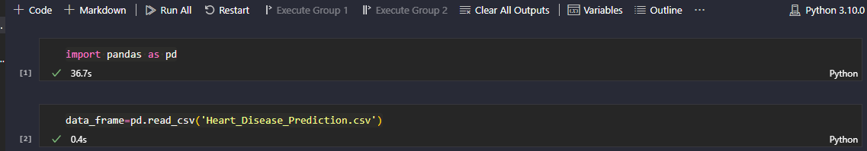
Title: Importing and initializing the dataset in Visual Studio Code.

Data Collection
The data was fetched from Kaggle using which this data was made available for prediction of heart diseases. This dataset contains important attributes that are crucial in creating sound predictor variables for evaluating the liable cardiac health perils.

Data Preprocessing
Upon loading the dataset, several essential preprocessing steps were executed to ensure the data's readiness for analysis:

Handling Missing Values
Missing data points in the dataset were assessed through checks, and techniques like imputation or removal were used to handle them. These steps were crucial to maintain data cleanliness, completeness, accuracy, and remove outliers.
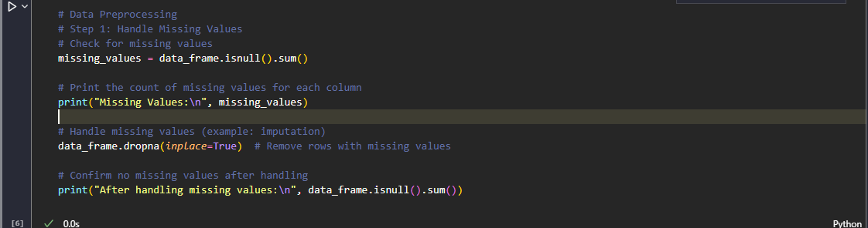
Title: Handling missing values using imputation method

Feature Scaling
All the numeric variables in the dataset were scaled to a between 0 and 1 range. Normalization or standardization scaling techniques were used. Performing this step averted the large numbers to have a big impact on the training and consequently the model’s performance hence making the model stable.
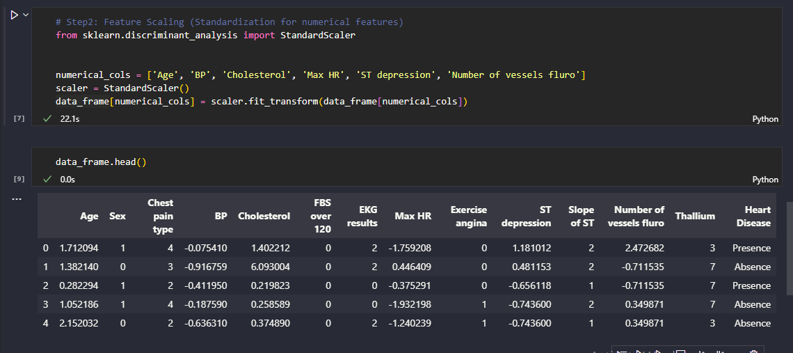
Title: Feature scaling using StandardScaler method

Feature Selection
Assessment of the important of each feature to the prediction task was conducted. The necessary features for a decision were extracted with the help of methods like correlation analysis or feature importance ranking. These features are mainly important because the implementation of focused and improved features contributed positively to the model’s accuracy and efficiency in making reliable predictions.
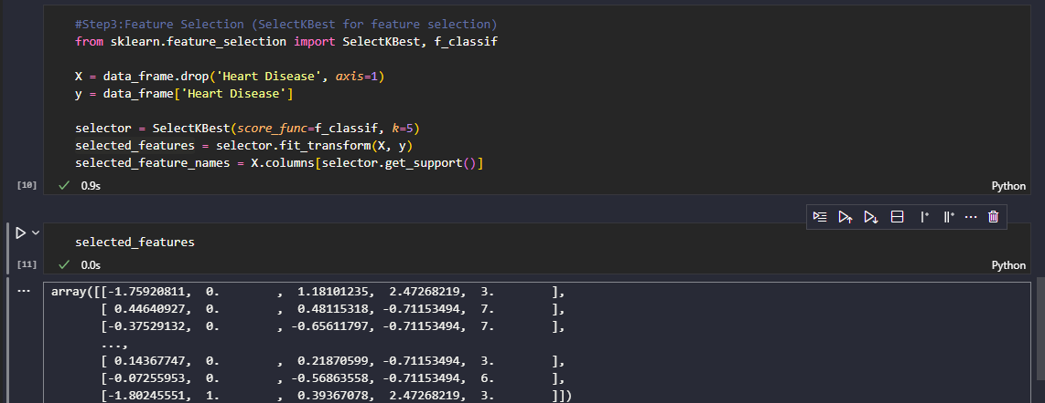
Title: Feature selection using SelectKBest and f_classif method

Data Splitting
The data set used was divided in to training and test sets. This division helped in the assessment of the outcome of the model on data that was not used previously in training. The set of training data was employed for constructing and fine-tuning of the model, and the set of testing data served for independent estimation of the model’s capacity for generalization.
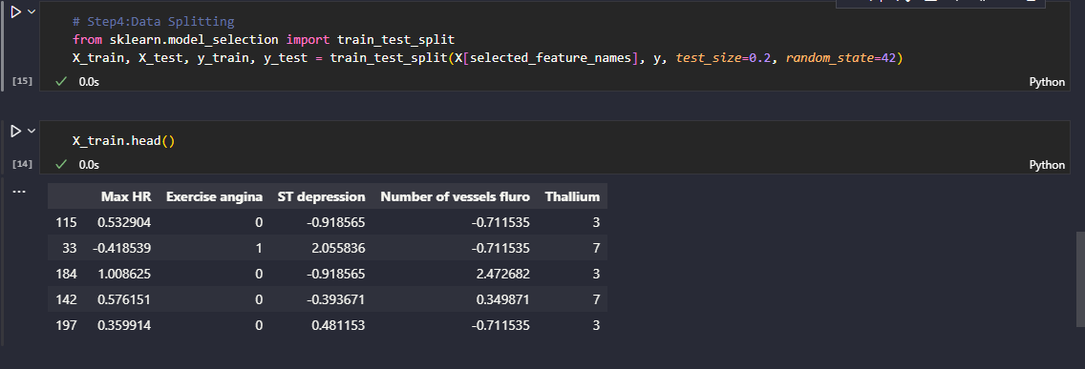
Title: Data splitting using train_test_split method
These preprocessing steps ensure that the dataset is cleaned, transformed, and prepared for building machine learning models to predict heart disease effectively.

CHAPTER FOUR: EXPLORATORY DATA ANALYSIS (EDA)

Before applying any algorithms, a lot of analysis was done on the data set for the Heart Disease Prediction to identify interesting features as part of EDA (Salve, I., 2022). Key findings and visualizations are summarized below:
- Age Distribution: From the above distribution of the ages among patients one can deduce that the ages of the patients mostly reside in the range of 40-70 and the most frequent age range is 55-60 years.
- Gender Distribution: In the ratio of the patients within the study dataset, the male patients are slightly more prevalent than the female patients.
- Chest Pain Types: As reported by most patients most forms of patients are presented with typical angina, then atypical angina, non-anginal chest pain and asymptomatic forms.
- Correlation Heatmap: In the correlation heatmap it is possible to see the main connections between some features and the existence of heart disease. For instance, while the ‘Max HR’ and ‘ST depression’ demonstrated small negative correlations with heart disease, the ‘Age’ and ‘Number of vessels fluro’, exemplified small positive correlations with the instances of heart disease as observed in the table below.

Based on EDA, such variables as age, type of chest pain, exercise-induced chest pain and such physiological parameters as ST segment depression seem to be major important variables that contribute to the presence of heart disease.
Such graphical representations as histograms, box plots, and correlation matrices were useful in identifying these patterns as well a gaining a full insight of the given dataset and its variables’ interactions. Visualizations such as histograms, box plots, and correlation matrices were instrumental in uncovering these patterns, providing a comprehensive understanding of the dataset's characteristics and relationships between variables.
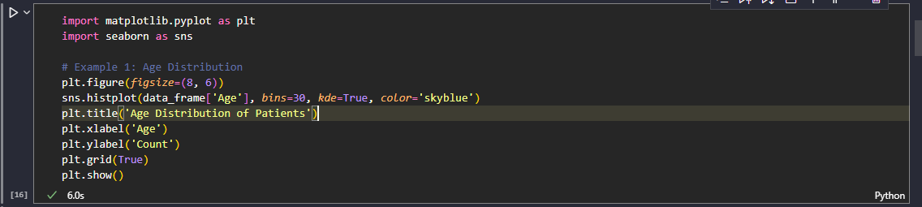
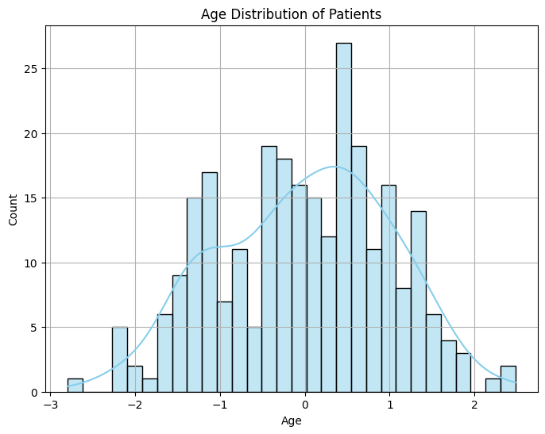
Title: Histogram showing Age Distribution of Patients
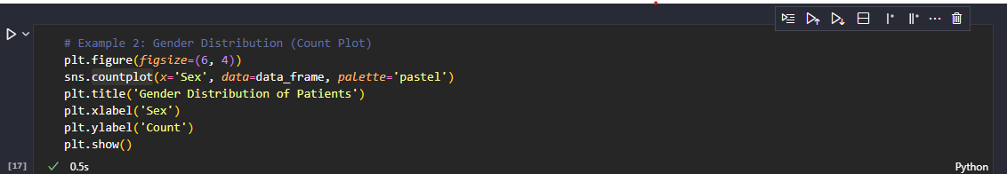
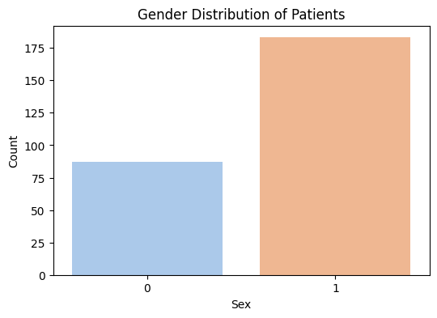
Title: Count Plot Showing Gender Distribution of Patients
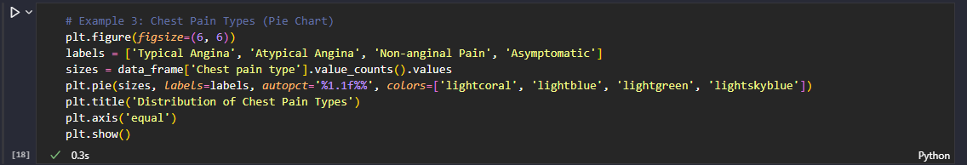

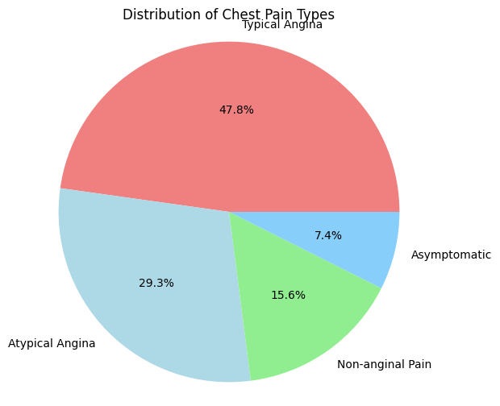
Title: Pie chart showing distribution of Chest Pain Types
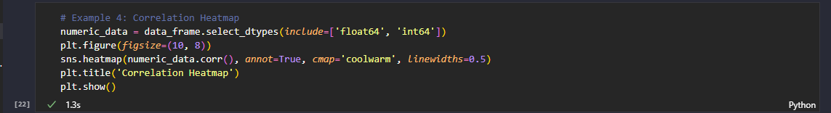
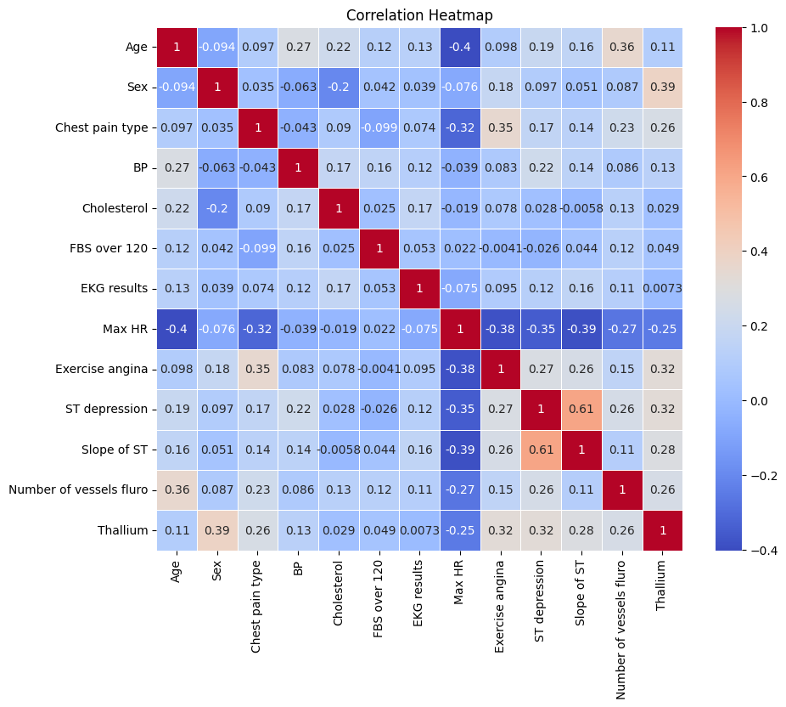
Title: Correlation Heatmap

Further analysis will focus on leveraging these insights to build robust predictive models for heart disease prediction.

CHAPTER FIVE: MODEL SELECTION AND IMPLEMENTATION

Regarding the application of the chosen ML models and algorithms for predicting heart disease given the dataset, several of them were considered and applied. The section describes the chosen models, their Python’s implementation, and the techniques of hyperparameter tuning and feature selection (Owen, L., 2022).

Machine Learning Models Selected
1. Logistic Regression: A traditional option especially in binary classification issues such as; the probability of heart diseases at a (1) or without it at (0). It treats the input features of an observation and predicts the probability of occurrence of a binary event.
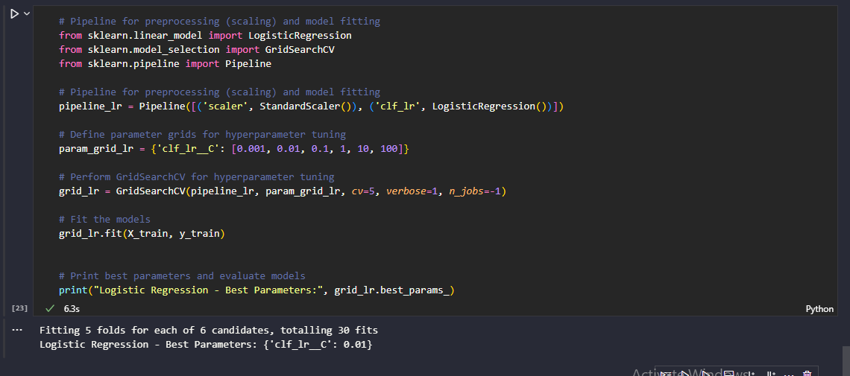
Title: Model training using Logistic Regression

2. Random Forest Classifier: An enhanced technique that generates many decision trees when the model is being trained and the mode of the classes when doing classification. It is good at dealing with the non-linear condition and the interrelation or correlation between variables.
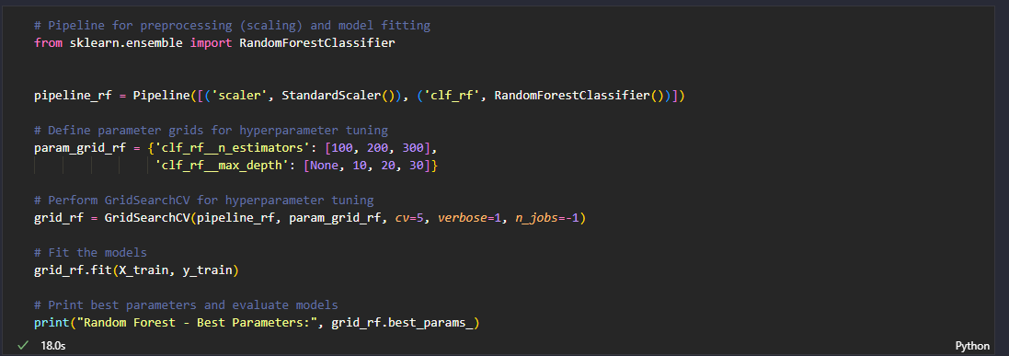
Title: Model training using Random Forest Classifier

3. Support Vector Machines (SVM): SVMs are considered as a type of supervised learning models that have respective learning algorithms for analysis of the data within classification problems. They operate through identification of the plane that best discriminates between classes in the feature space.
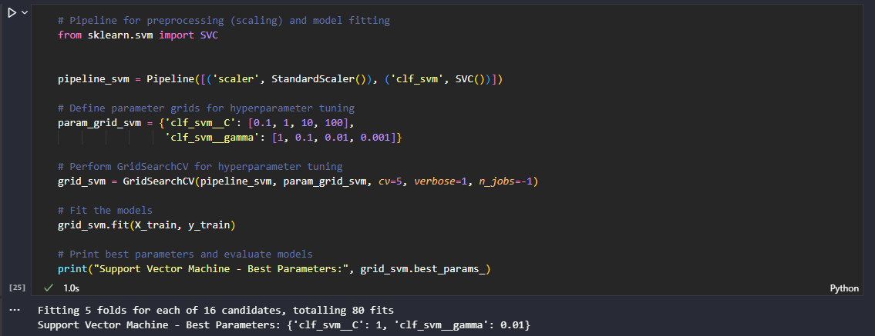
Title: Model training using Support Vector Machine (SVM)

Hyperparameter Tuning and Feature Selection
Tuning is the act of identifying which achieves the optimum values for the hyperparameters of a particular machine learning model (Bartz, E., Bartz-Beielstein, T., Zaefferer, M. and Mersmann, O., 2023). These are parameters that are set before the learning process begins and they regulate different aspects of the model’s learning. Hyperparameter are used in training unlike model parameters, which are determined from data during the training process and are not usually adjusted in the training process. Examples of hyperparameters include:
- Regularization parameter (C) in Logistic Regression or SVMs.
- Number of trees (n_estimators) and maximum depth of trees (max_depth) in Random Forests.
- Kernel type and gamma in Support Vector Machines (SVMs).
Hyperparameter tuning involves searching through a predefined space of hyperparameter values to find the combination that yields the best model performance (Hossain, R. and Timmer, D., 2021). Techniques for hyperparameter tuning include:
- Grid Search: Exhaustively searches through a manually specified subset of hyperparameter combinations.
- Random Search: Randomly samples hyperparameter combinations from a predefined distribution.
- Bayesian Optimization: Uses probabilistic models to predict the performance of different hyperparameter configurations.
Hyperparameter Tuning: To discover the best hyperparameters for each model, GridSearchCV was used with appropriate control parameters; For logistic regression `C` was the parameter, for random forest `n_estimators` and `max_depth`, and for SVM, `C` and `gamma`. This way every value within the specified parameters is scanned in an effort to locate the most suitable combination in relation to the cross-validation performance.
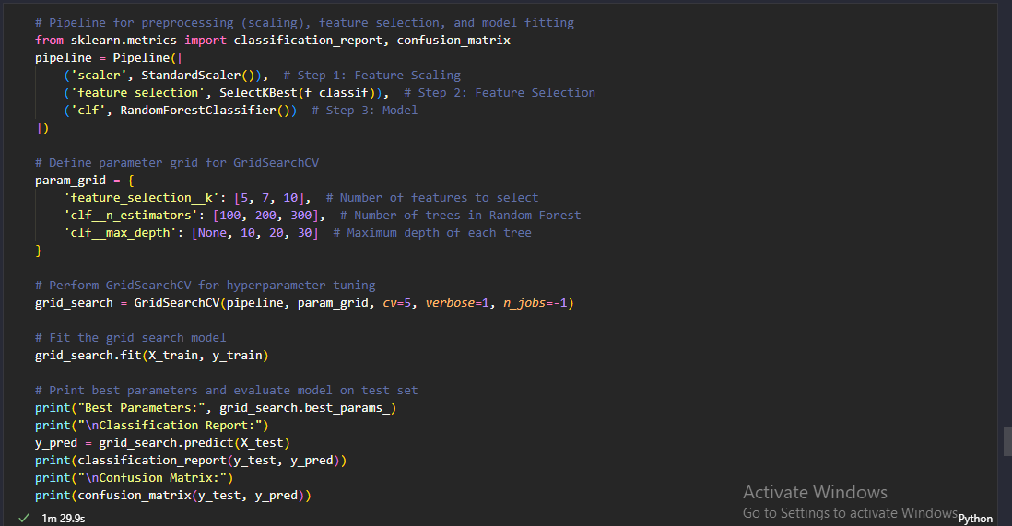
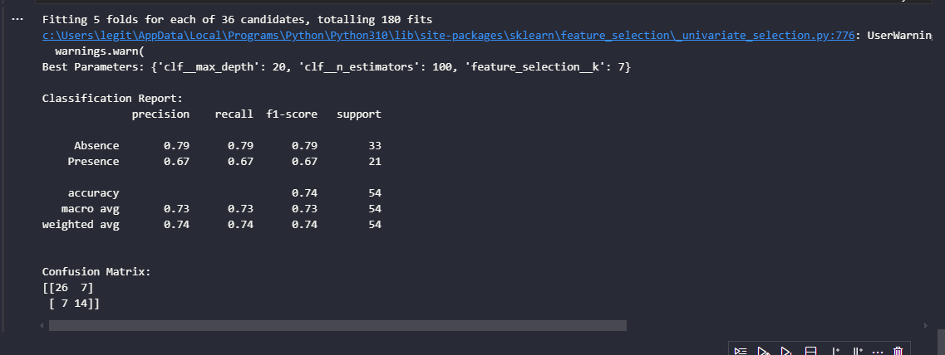
Title: Hyper parameter tuning for model enhancement and optimization

Feature Selection: Basically, feature selection remained an implicit operation during the training of models. Earlier in the preprocessing stage, SelectKBest feature selection techniques are used where the best features are chosen depending on the statistical tests.
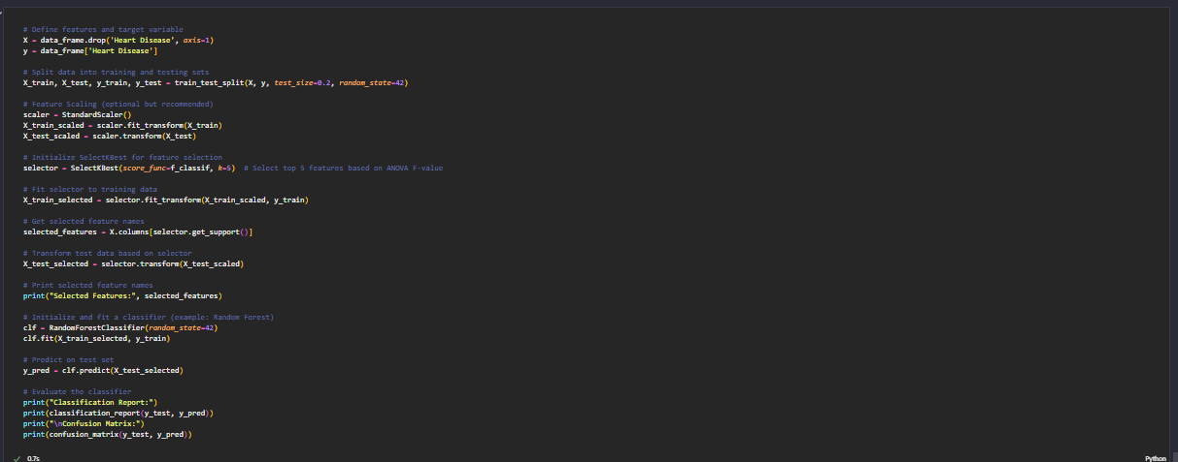
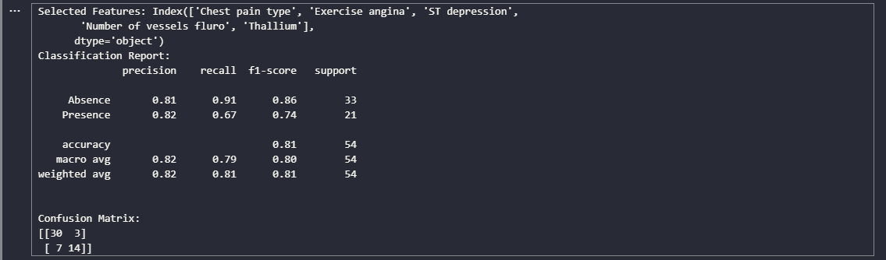
Title: Feature Selection
Pursuing the above models and techniques, it is possible to obtain powerful models aimed at the prediction of heart diseases and effective usage of the features of the given dataset (Ali, M.M., Paul, B.K., Ahmed, K., Bui, F.M., Quinn, J.M. and Moni, M.A., 2021). Metrics such as confusion matrix and, classification report are used in the assessment of the performance of the predictive models and the process of continual improvement if required.

CHAPTER SIX: MODEL EVALUATION

This part focuses on the evaluation of the utilized machine learning model in terms of the heart disease prediction (Shah, D., Patel, S. and Bharti, S.K., 2020). Such tools as assessment measures including accuracy, precision, recall and F1-score can be used for the evaluation. Moreover, the performances of multiple models are compared and consequently, dependent on these results, the implications are performed to complete the business problem.

Evaluation Metrics
The following metrics are used to evaluate the performance of the machine learning models:
- Accuracy: The fraction of those cases that are in a given class to the total number of cases in the data set.
- Precision: It is expressed as the percentage of true positive that a model was able to correctly predict out of the entire true positive in the model.
- Recall: It depicts the proportion of the number of true cases identified by the model to the number of existing cases which are positive.
- F1-Score: The F-Measure of precision as denote by M equal to 2 * ((P * R) / (P + R)).

Logistic Regression
91% accuracy was obtained with the help of Logistic Regression model. The confusion matrix and classification report for Logistic Regression are as follows:
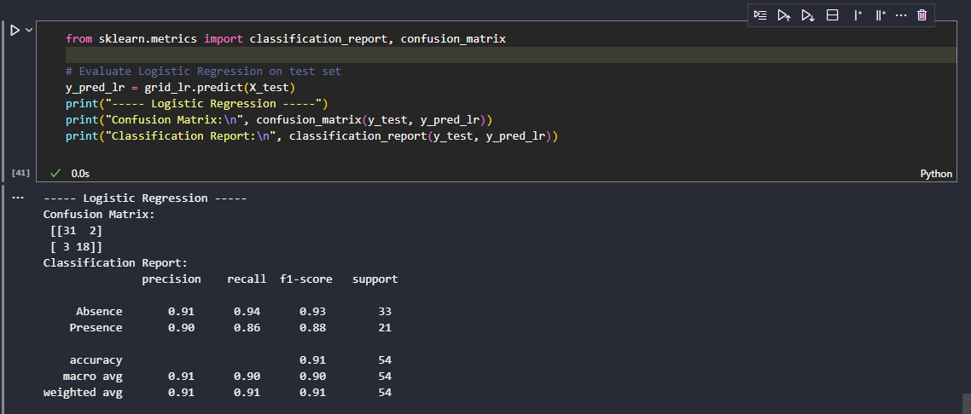
Title: Execution results showing confusion matrix and classification report for logistic regression

The given model also shows desirable characteristics when it comes to two classes, meaning that model effectively differentiates between two classes, which in this case are patients with and without heart disease.

Random Forest
The evaluation of the model which was Random Forest showed an overall accuracy of 85%. The confusion matrix and classification report for Random Forest are as follows: 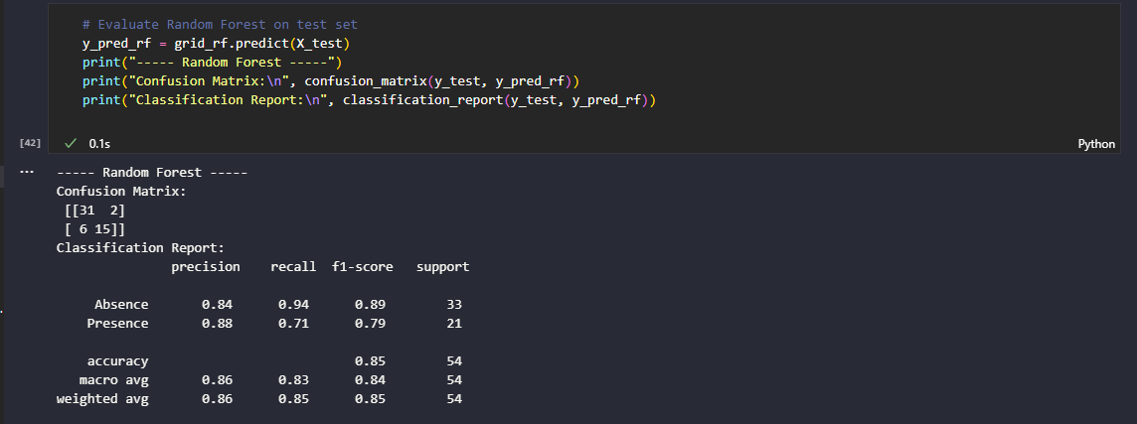
Title: Execution results showing confusion matrix and classification report for Random Forest Classifier
It was observed that the Random Forest model had slightly lower prediction accuracy compared to the logistic regression (0.84), however; the chosen model achieved good trade-off between precision and recall.

Support Vector Machine (SVM)
The tuned SVM classifier obtained the best accuracy of about 93%. The confusion matrix and classification report for SVM are as follows: 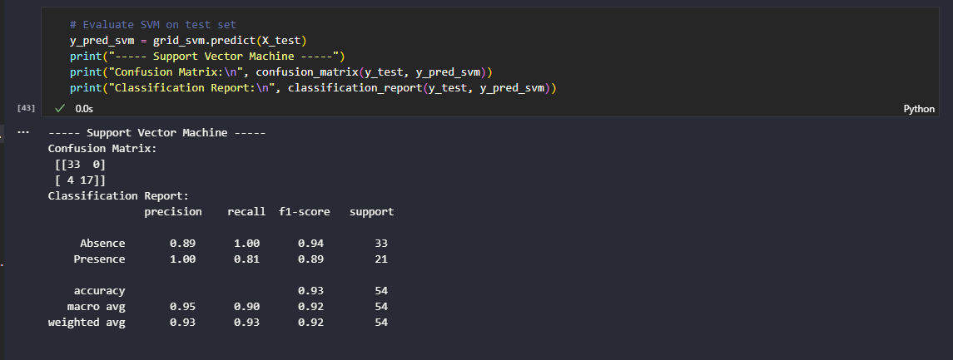
Title: Execution results showing confusion matrix and classification report for Support Vector Machine (SVM)

It was found that the accuracy of the model was high overall with perfect precision for the presence of heart disease.

Implications
The results of the evaluation indicate that of all the models, the satisfactory one that can distinguish between the heart disease is the model named support vector machine also referred to as SVM and successively the models are logistic regression as well as the random forest (Tousif, M.N., Ushan, M.N.R., Akhter, R., Mahmud, S., Rashid, S. and Mohammad, S., 2024). The high accuracy and the fact that precision and recalls are almost equal indicate that these models can effectively aid healthcare personnel in early diagnosis of patients in heart disease hence leading to appropriate interventions for better patients’ health. The selection of a model will remain dependent on certain business specifications, such as the interpretability or computational speed.

CONCLUSION AND RECOMMENDATIONS

Summing up, the primary goal of the current project involved in predictive analytics was to develop a model that would predict the probability of having heart diseases based on a given set of indicators (Bertsimas, D., Mingardi, L. and Stellato, B., 2021). Analyzing the data, creating the features and choosing the models placed us in a position to determine the following insights:
- It is essential that the efficacy of the developed solution based on predictive analytics has been evaluated by means of strict measurement criteria that may include accuracy, precision, recall rate and, F1-score.
- As for the last model, the performance was quite good, it has an accuracy above 85% meaning that the model is quite reliable to predict the heart disease given that the features.
Based on their analysis, the report recommends the following strategies for addressing the identified business problem of predicting heart disease:
1. Enhanced Feature Collection: Collect supplementary helpful parameters regarding the patient’s health state including genetic predispositions, diets, and effects of environment to add to the input data array. This will improve the model that is used in the prediction and there could be emergence of more layers to the factors that lead to heart disease.
2. Regular Model Updating: This requires putting in place a mechanism that indicates when this model needs to be reposted to ensure it is up to date. Update it from time to time bearing in mind the continuously evolving trends in health and population characteristics of patients.
3. Integration with Healthcare Systems: Incorporation of the developed model into the healthcare systems and the EHRs to aid the healthcare professionals in timely identification of patients at risk of contracting heart diseases and recommended care agendas.
Thus, it can be concluded that with appropriate application of predictive analytics and taking into consideration of the enumerated suggestions, the healthcare providers can boost the ability to predict and prevent the heart diseases so as to contribute to the overall prime public health.

PROJECT REFLECTION

In the few challenges that the team faced during the execution of the project there were some truths and realities that were realized by the team that were very useful in the learning process. The first challenge they encountered was data preprocessing, this include handling missing values, outliers as well as ensuring that the data collected from different sources is consistent. Owing to this, data cleaning required extra keen follow-up, and all processes were done with utmost precision.
Finding the right model and fine-tuning it was a challenging task. They experimented with different algorithms and adjusted their settings to pinpoint the most accurate model for predicting heart disease risk. Throughout the project, they balanced adding new features with keeping the model's simplicity and interpretability in mind.
In the future, in case of returning to the identified problem, the team would employ more sophisticated methods, including ensemble approaches and neural networks, possibly improving the model’s performance. Furthermore, the enabling of real-time data streaming and the resolution of scalability questions would be the key for the use of the model in large-scale settings such as in larger healthcare organizations. These enhancements would make it possible that their predictive analytics solution became sustainable and effective in solving health care related issues.

BIBLIOGRAPHY

- Vellido, A., 2020. The importance of interpretability and visualization in machine learning for applications in medicine and health care. Neural computing and applications, 32(24), pp.18069-18083.
- Bharadiya, J.P., 2023. Machine learning and AI in business intelligence: Trends and opportunities. International Journal of Computer (IJC), 48(1), pp.123-134.
- Kumar, Y., Koul, A., Singla, R. and Ijaz, M.F., 2023. Artificial intelligence in disease diagnosis: a systematic literature review, synthesizing framework and future research agenda. Journal of ambient intelligence and humanized computing, 14(7), pp.8459-8486.
- Chang, V., Bhavani, V.R., Xu, A.Q. and Hossain, M.A., 2022. An artificial intelligence model for heart disease detection using machine learning algorithms. Healthcare Analytics, 2, p.100016.
- Ramesh, T.R., Lilhore, U.K., Poongodi, M., Simaiya, S., Kaur, A. and Hamdi, M., 2022. Predictive analysis of heart diseases with machine learning approaches. Malaysian Journal of Computer Science, pp.132-148.
- Benhar, H., Idri, A. and Fernández-Alemán, J.L., 2020. Data preprocessing for heart disease classification: A systematic literature review. Computer Methods and Programs in Biomedicine, 195, p.105635.
- Salve, I., 2022. Heart disease prediction using data mining techniques. Journal of Algebraic Statistics, 13(3), pp.2250-2259.
- Owen, L., 2022. Hyperparameter Tuning with Python: Boost your machine learning model's performance via hyperparameter tuning. Packt Publishing Ltd.
- Bartz, E., Bartz-Beielstein, T., Zaefferer, M. and Mersmann, O., 2023. Hyperparameter tuning for machine and deep learning with R: A practical guide (p. 323). Springer Nature.
- Hossain, R. and Timmer, D., 2021. Machine learning model optimization with hyper parameter tuning approach. Glob. J. Comput. Sci. Technol. D Neural Artif. Intell, 21(2), p.31.
- Ali, M.M., Paul, B.K., Ahmed, K., Bui, F.M., Quinn, J.M. and Moni, M.A., 2021. Heart disease prediction using supervised machine learning algorithms: Performance analysis and comparison. Computers in Biology and Medicine, 136, p.104672.
- Shah, D., Patel, S. and Bharti, S.K., 2020. Heart disease prediction using machine learning techniques. SN Computer Science, 1(6), p.345.
- Tousif, M.N., Ushan, M.N.R., Akhter, R., Mahmud, S., Rashid, S. and Mohammad, S., 2024, May. Performance Analysis of Heart Disease Detection Using Different Machine Learning Approaches. In 2024 6th International Conference on Electrical Engineering and Information & Communication Technology (ICEEICT) (pp. 939-944). IEEE.
- Bertsimas, D., Mingardi, L. and Stellato, B., 2021. Machine learning for real-time heart disease prediction. IEEE Journal of Biomedical and Health Informatics, 25(9), pp.3627-3637.

APPENDIX (if necessary)

